# Manual Test Plan

## 

1. New sign up page is like

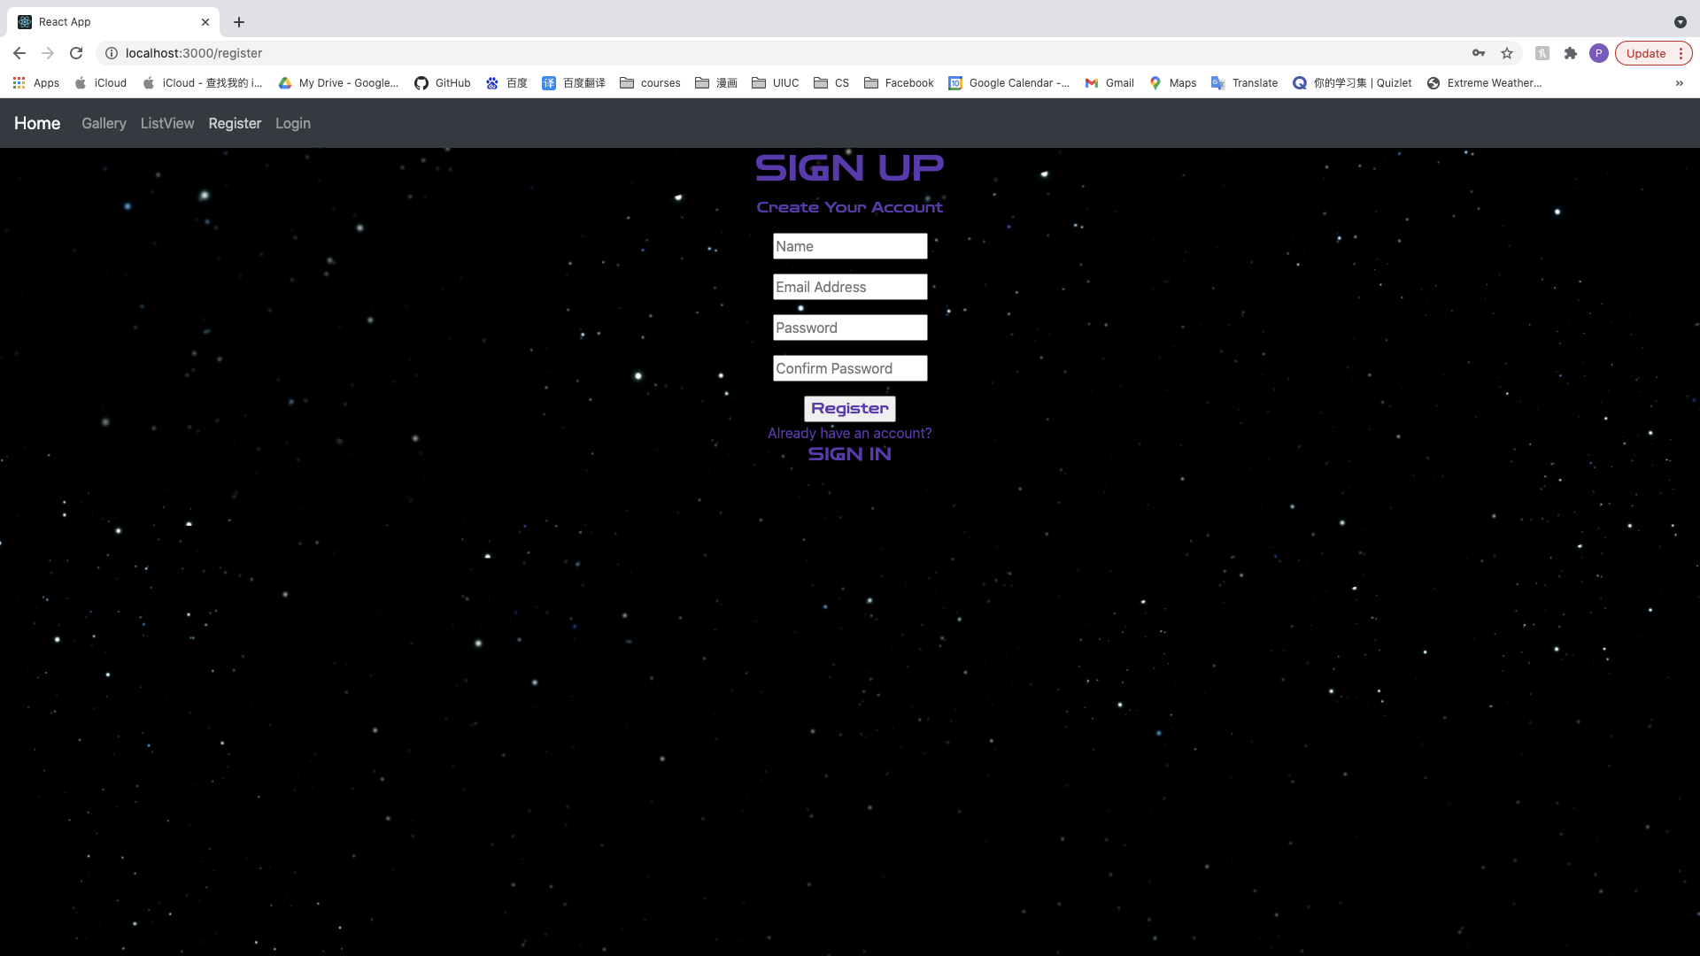

Instead of

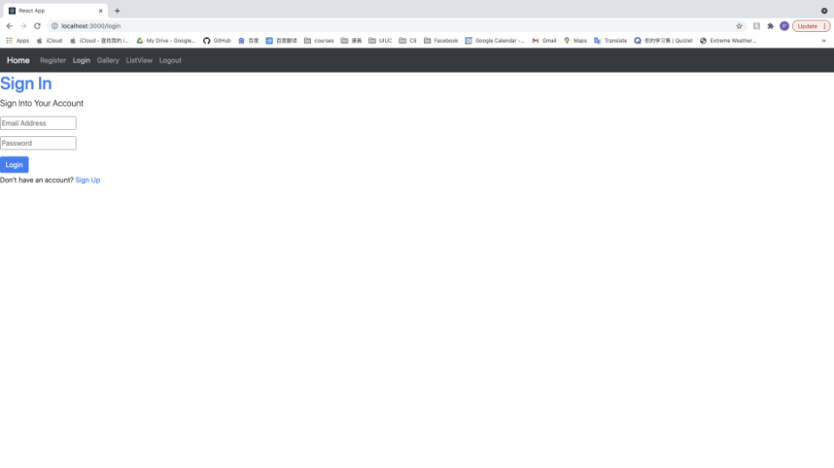

1. New login page is like

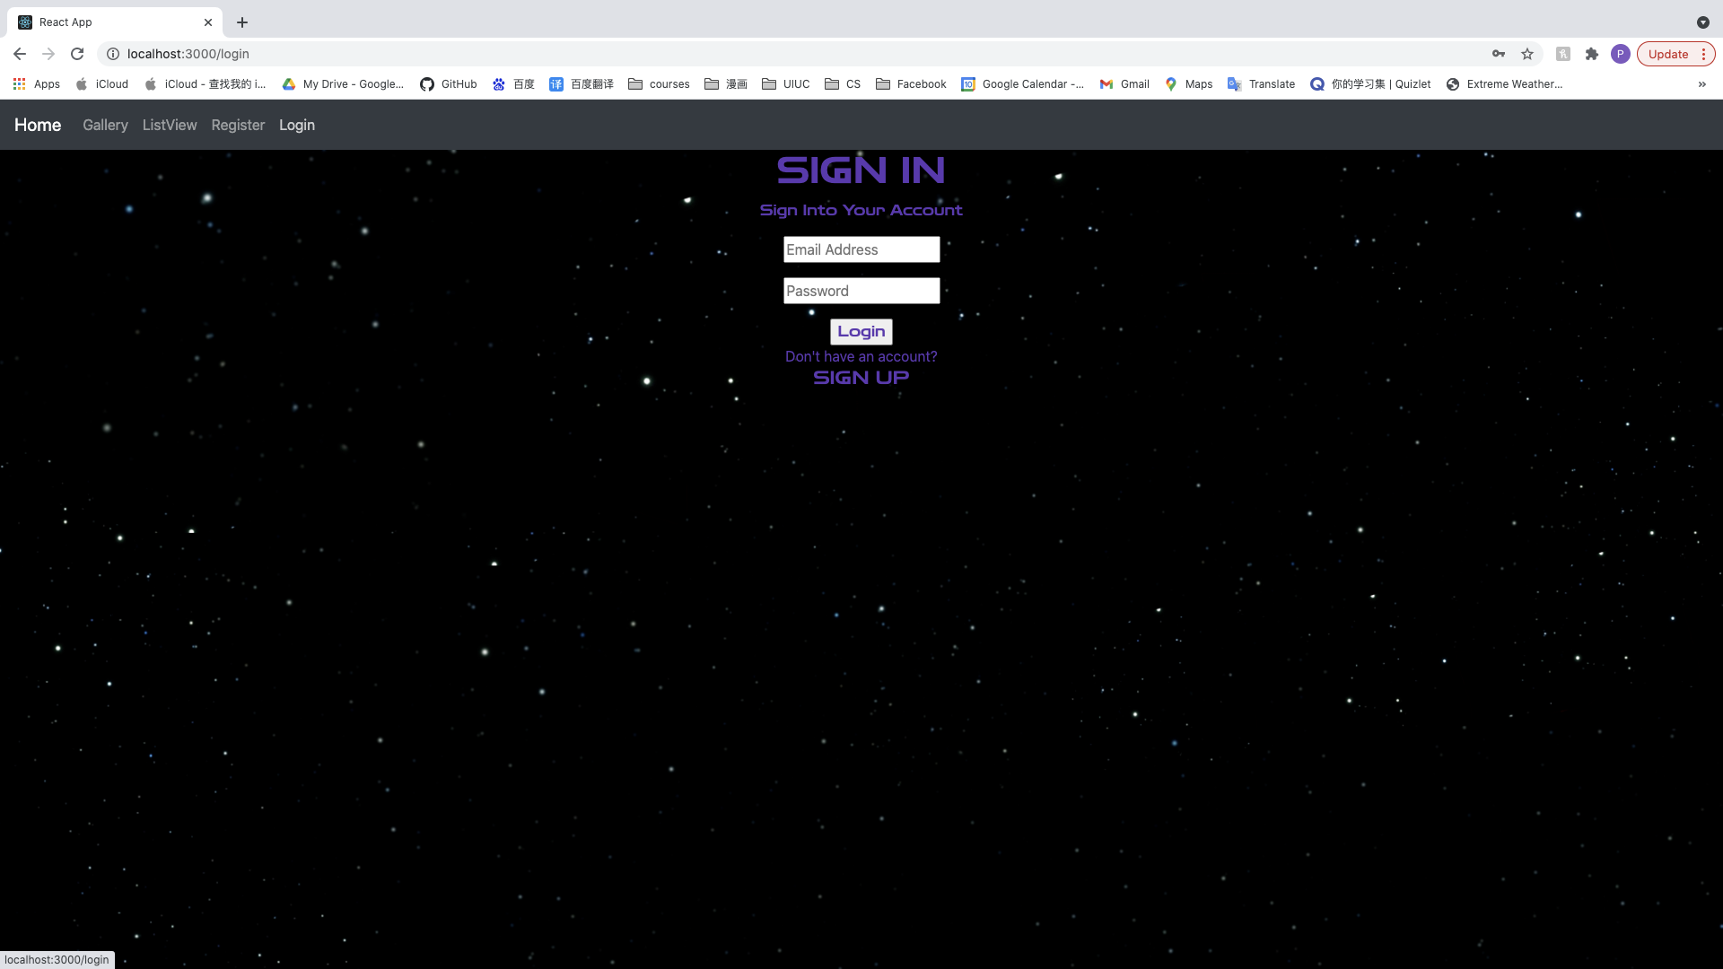

Instead of

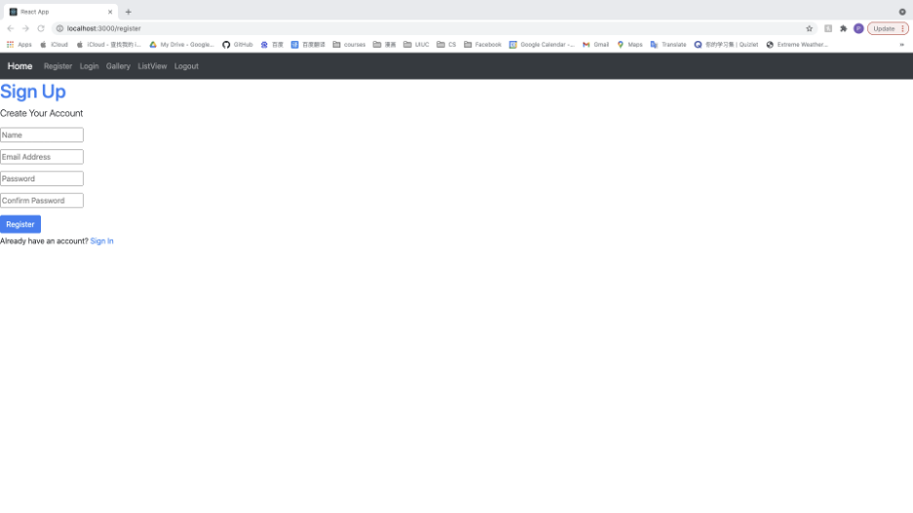

1. After successfully login, the navbar will change like

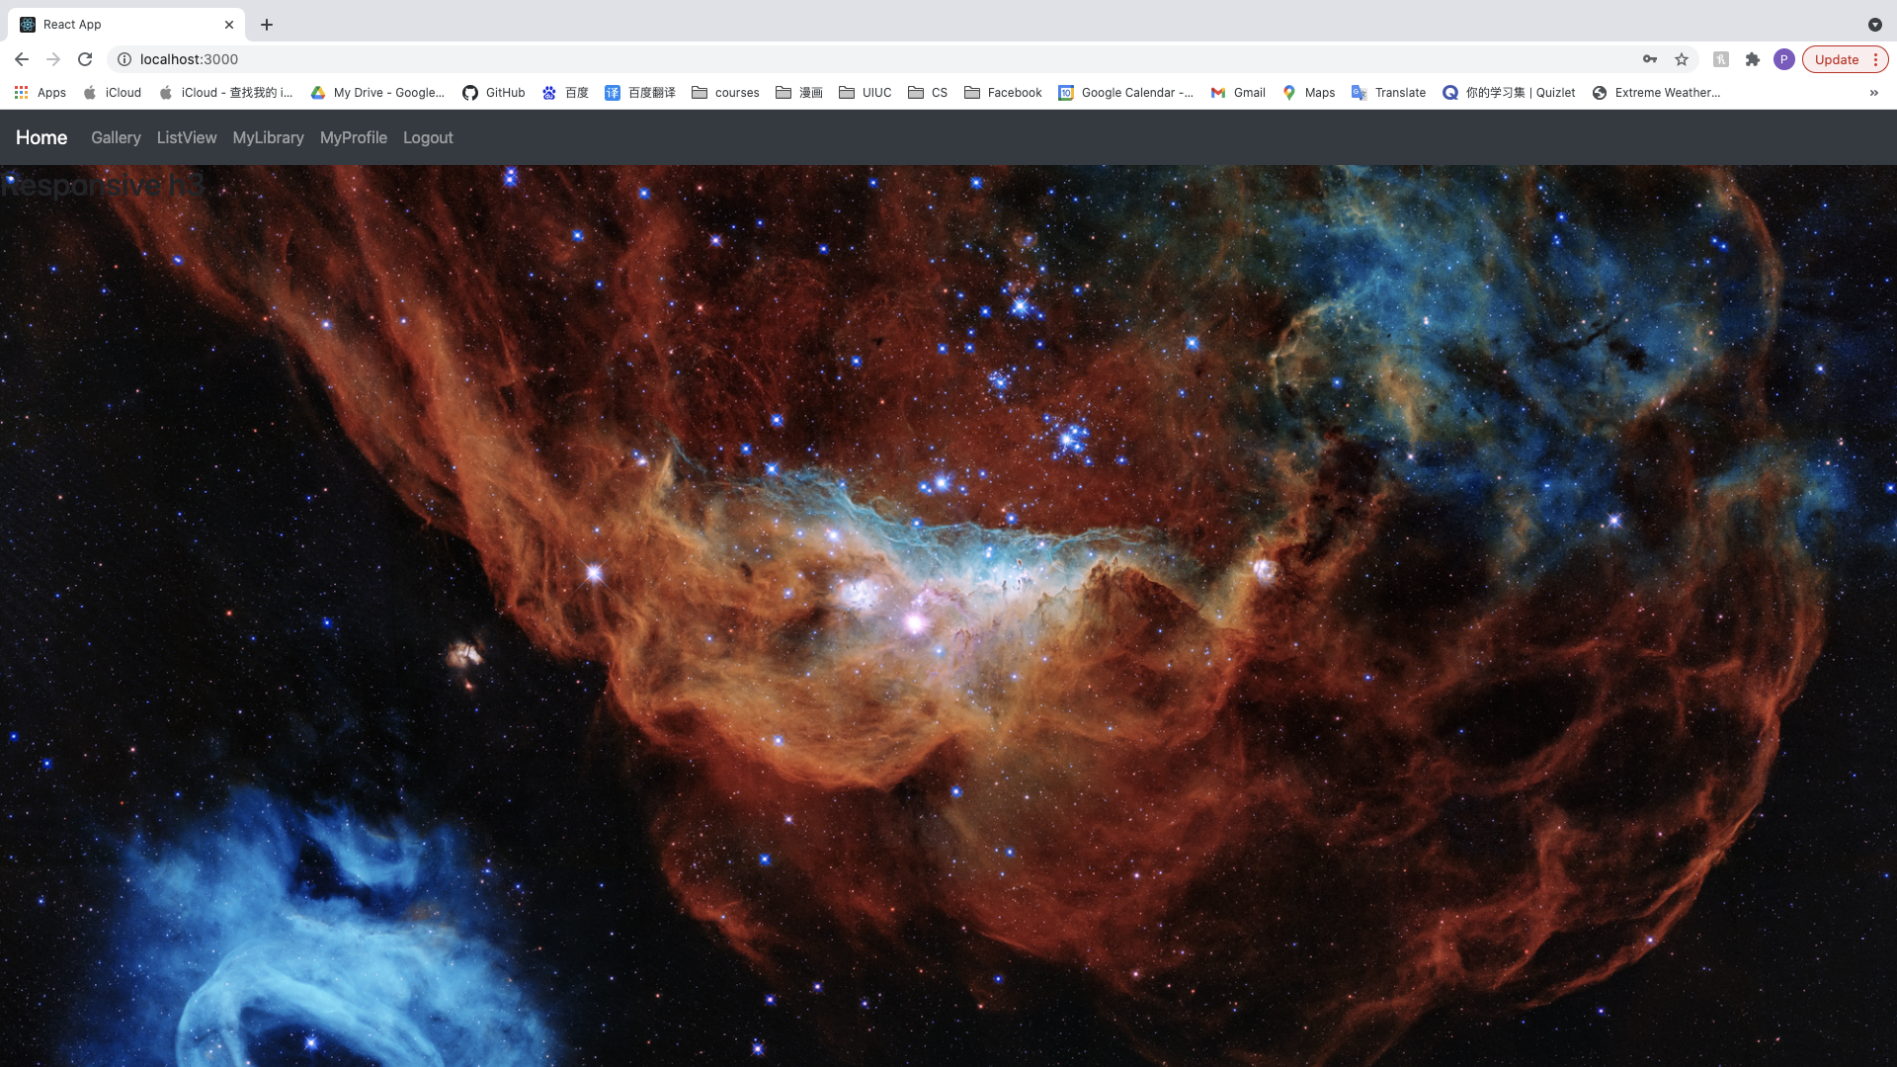

1. New listview is like

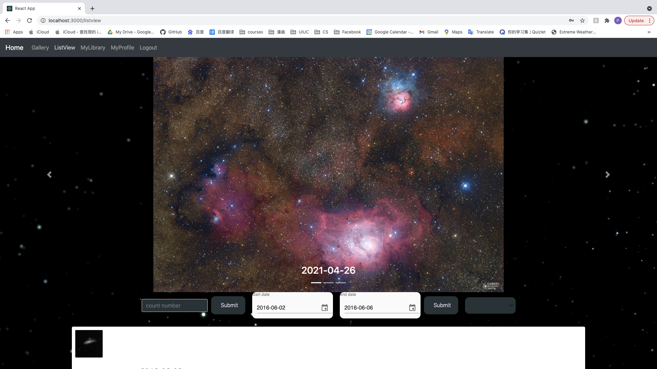

Instead of

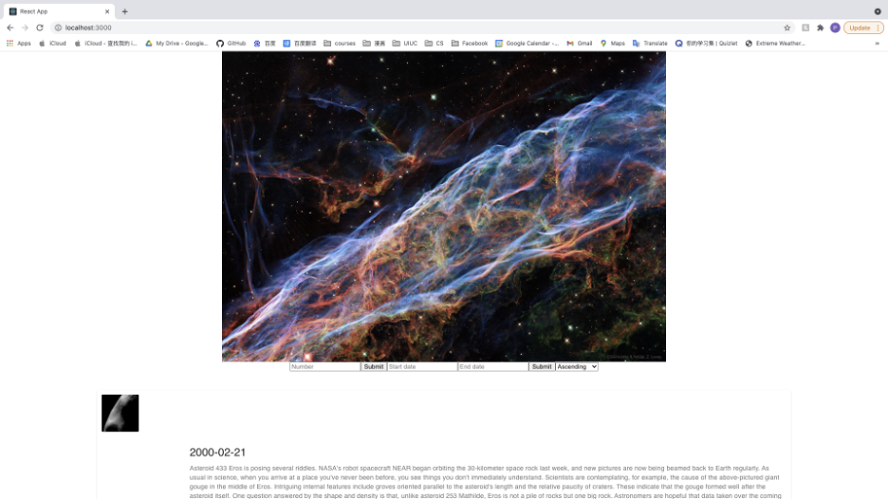

1. There’s a 3-image carousel at the top of listview instead of a single image
2. The carousel will auto change the image
3. Click the arrow button aside to can also change the carousel displaying image
4. I also changed the button of listview

From 

To



1. Click the date button will show like

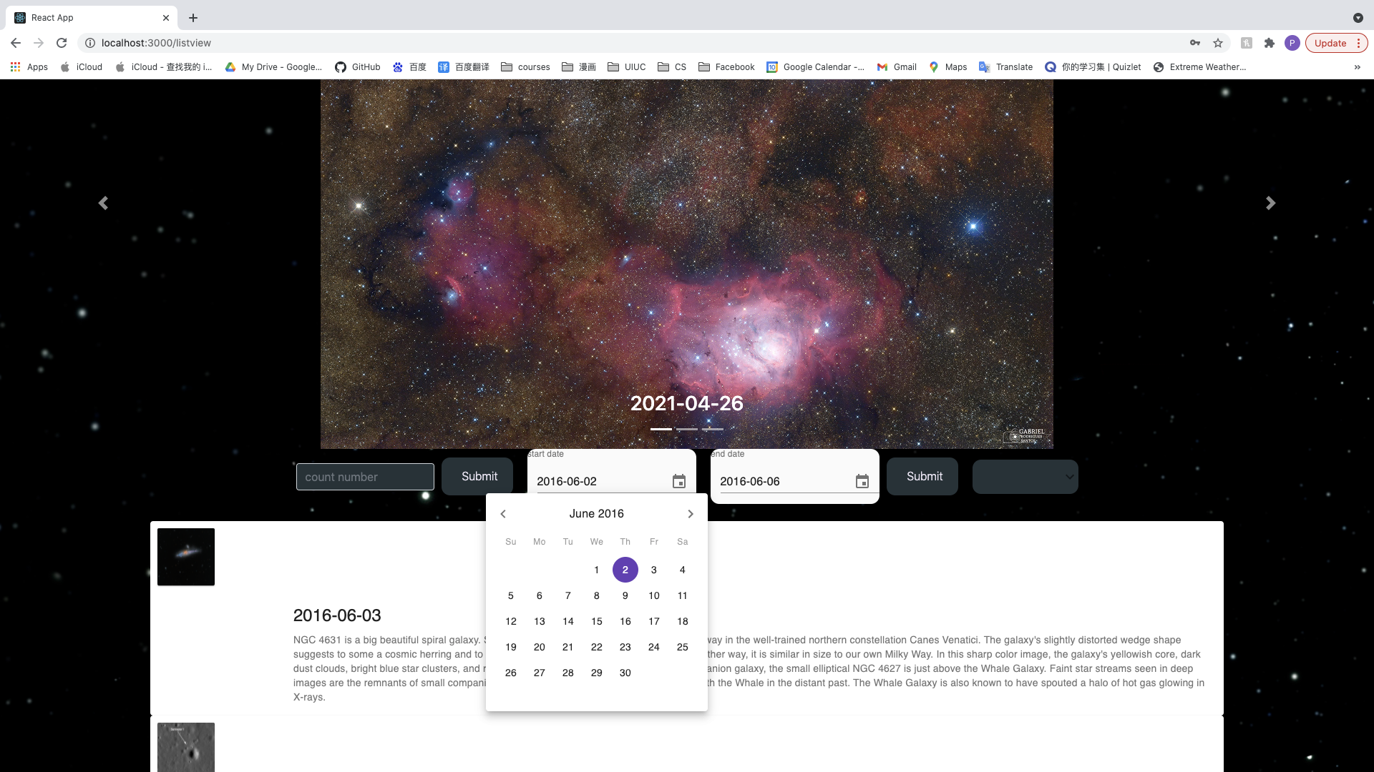

1. You can still manually input the date instead of choose
2. Click MyLibrary should redirect to a page like this

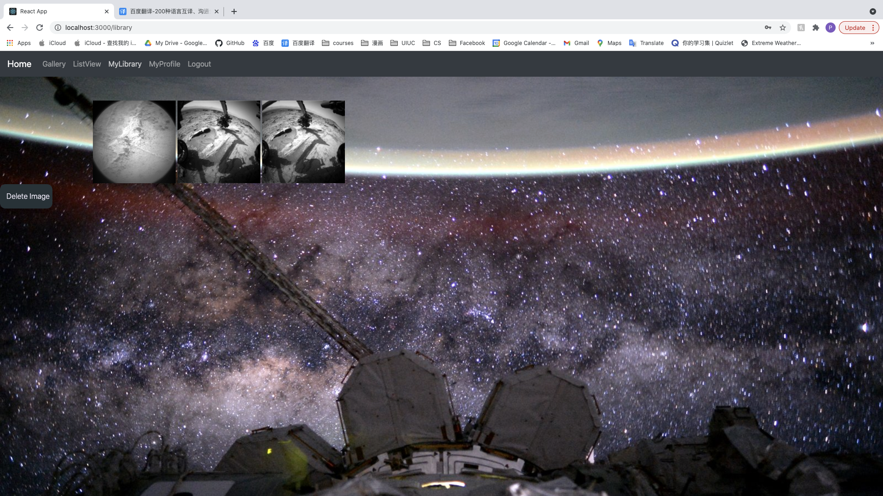

1. Clicking any image will display the notes of it like this

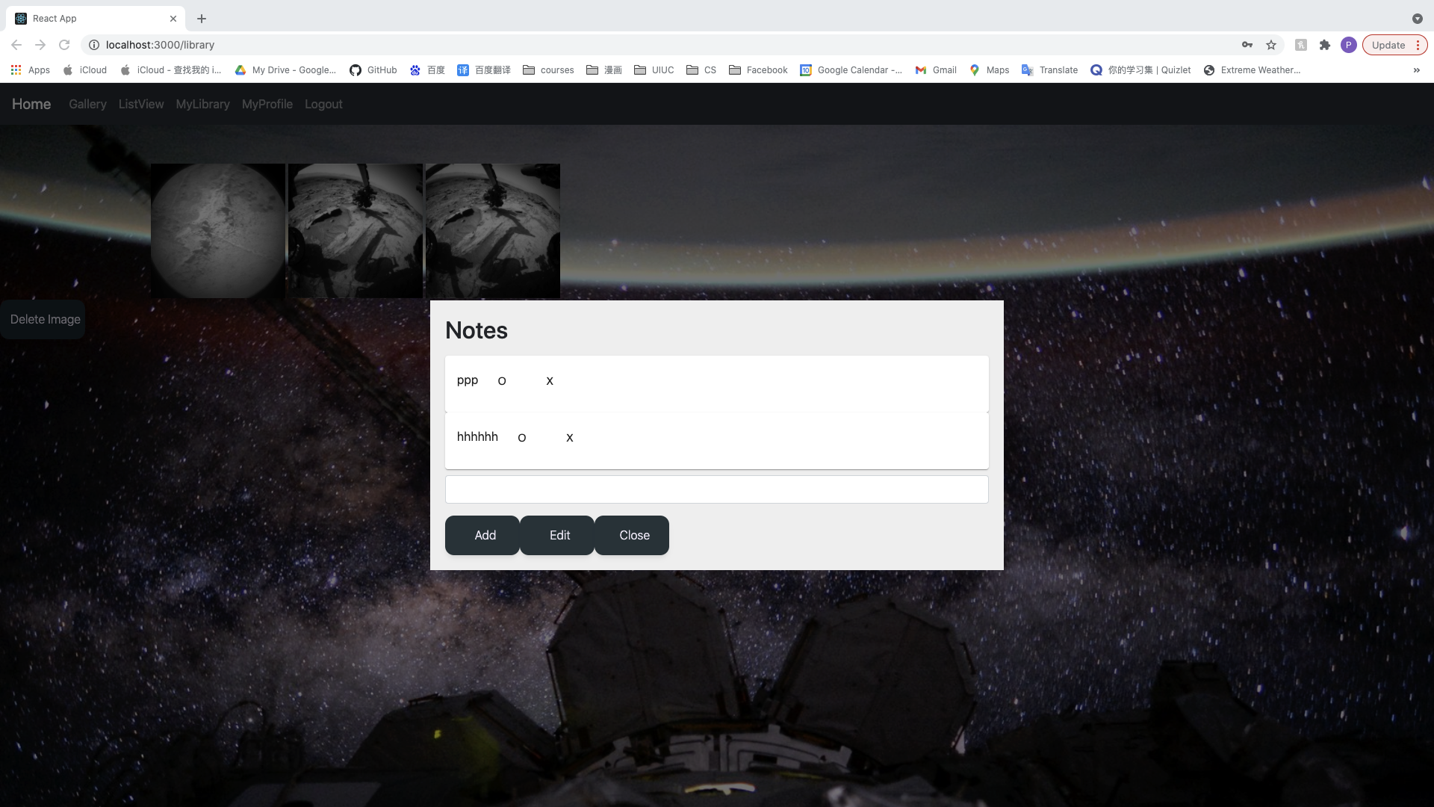

1. Input any message in the text editor and click Add button will add the message immediately

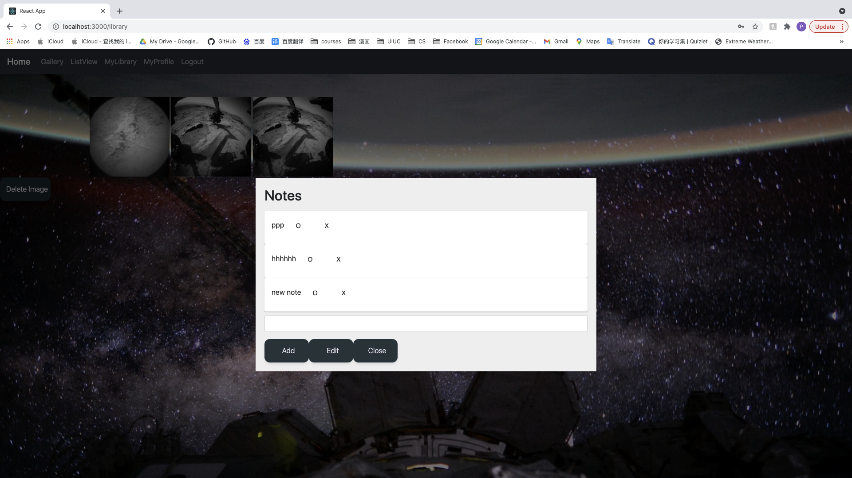

1. You should be able to continually add notes in the window

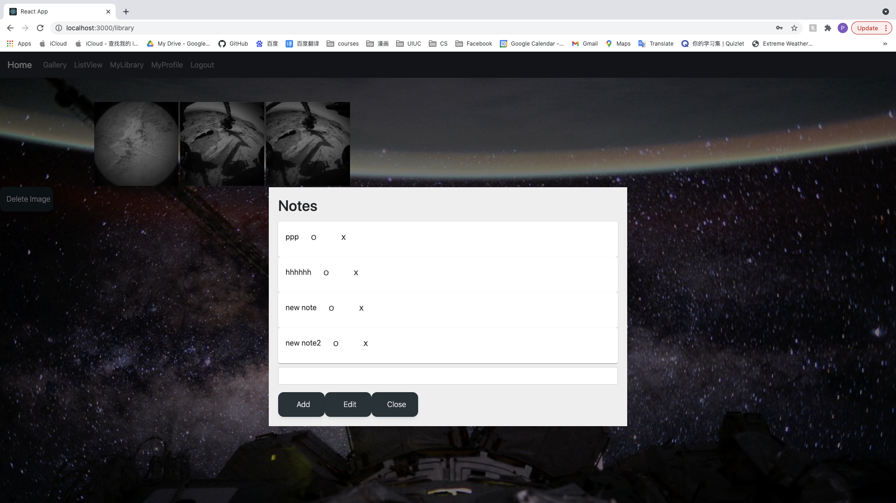

1. Click any ‘o’ button and input message in the text editor, then click ‘Edit’ can edit that note

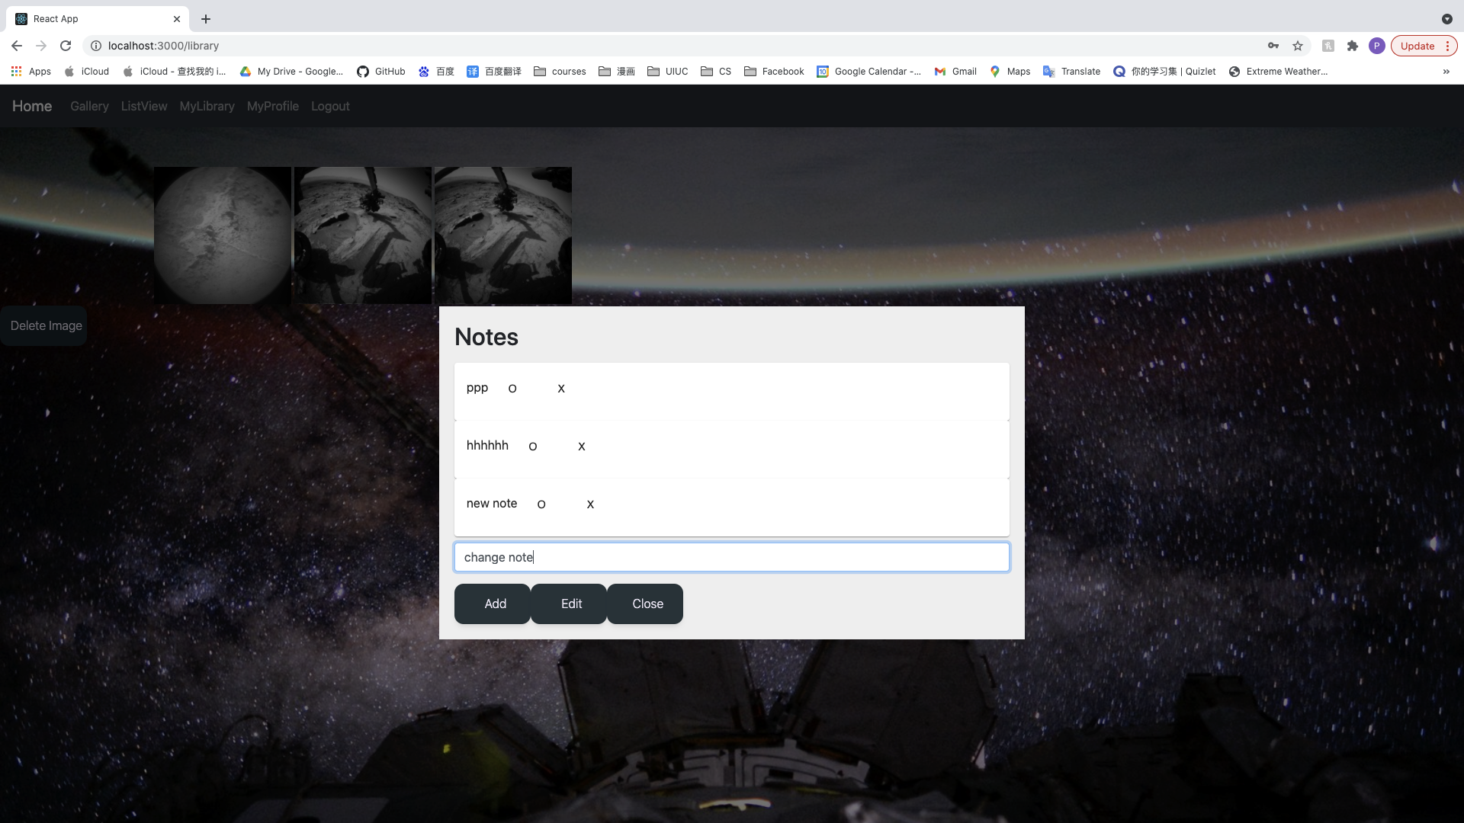

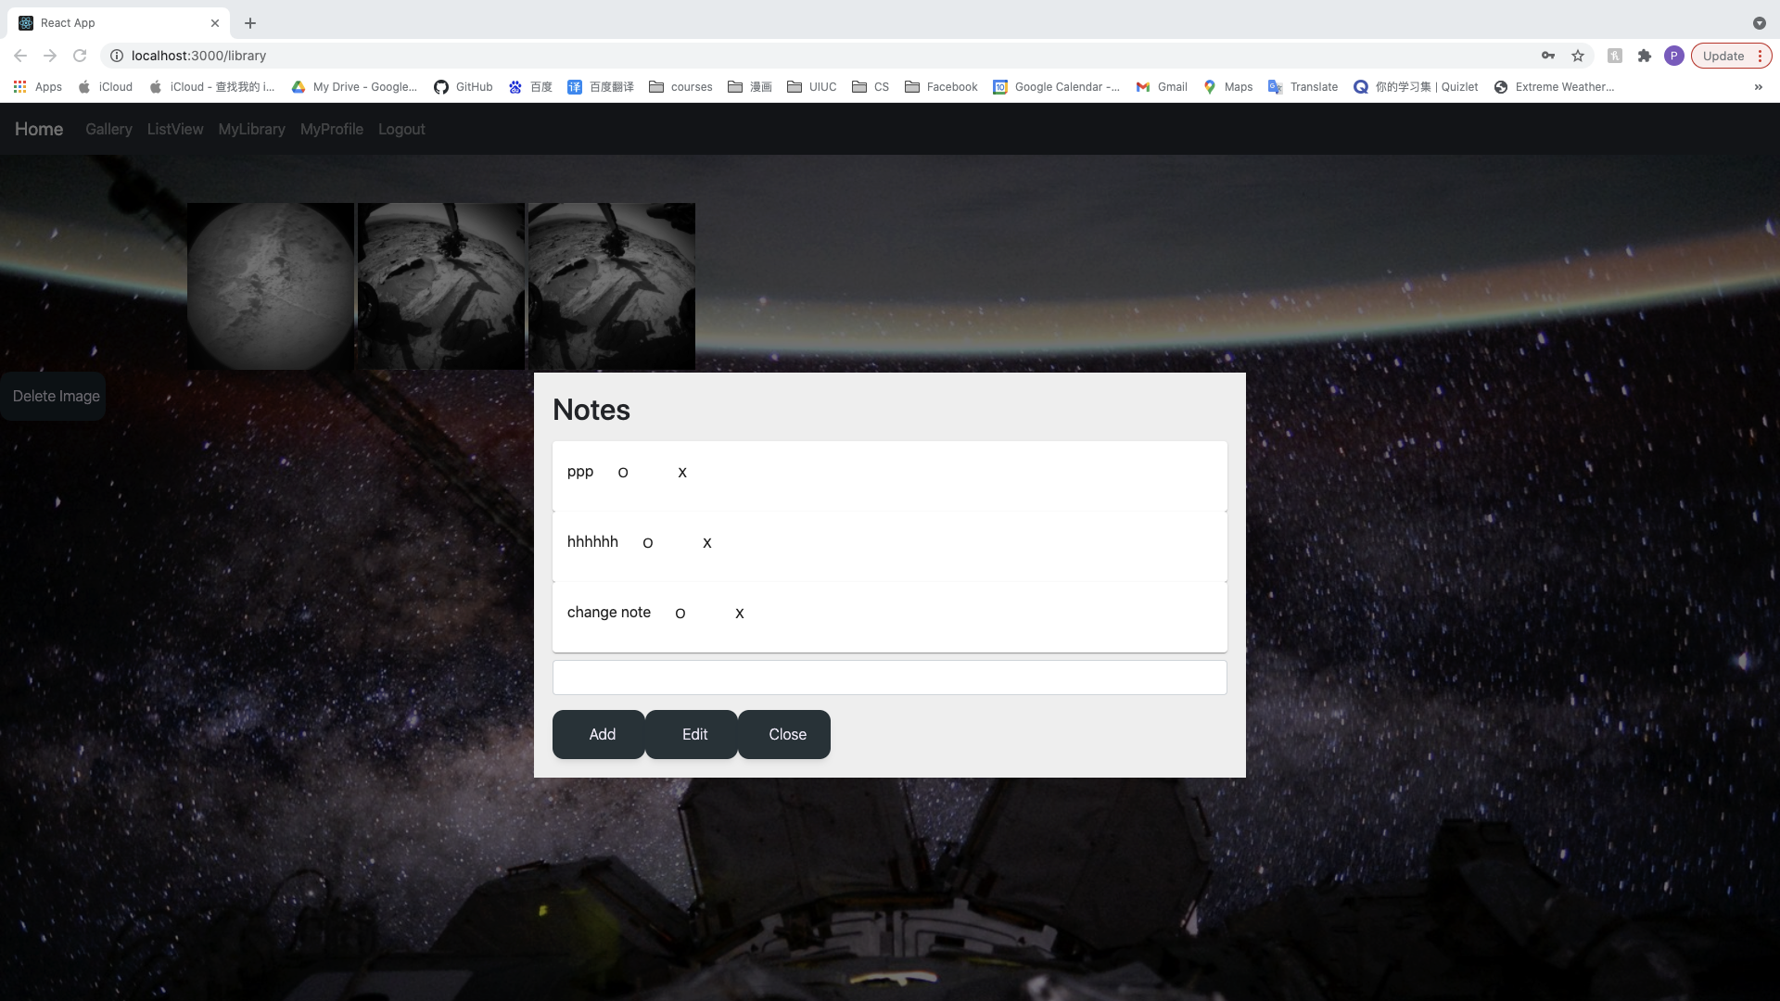

1. Input message first, then click ‘o’ then click ‘Edit’ button can also change the note
2. Click ‘o’ and input messages but click Add will add a new note rather than edit that note
3. Click the ‘X’ button can delete the note immediately

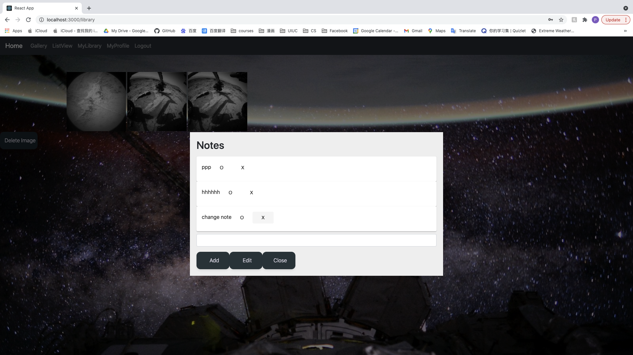

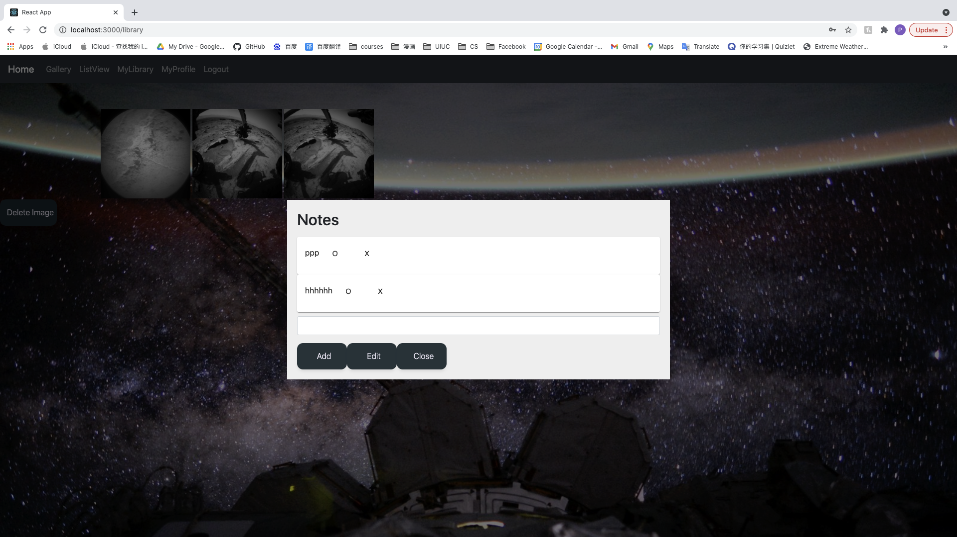

1. Click ‘Close’ button will close popup window
2. Click ‘Logout’ in the navbar will become

